WHANGANUI BAY MAORI RESERVATION TRUST

PAPAKAINGA O NGĀTI TE MAUNGA

POLICY NAME: HEALTH AND SAFETY POLICY | POLICY NUMBER: P004
ORIGINAL AUTHORISATION: Chairperson | DATE: Mar 2017

Version Control:
Serial | Date | Change | Responsible | Sign

Associated policies: The associated policies include:
- Whanganui Bay Maori Reservation Trust Charter 001.

Purpose
- The policy aims to ensure the Trust continually improves and achieves excellence in the management of Health and Safety.
- The Trust aims to achieve this by building awareness, involvement and individual commitment to safety.
Principles
- The policy must be in keeping with our vision and values for management of the reservation, our people and activities within the reservation.
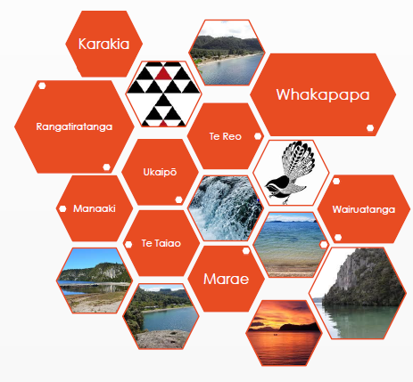

- The Trust is also committed to complying with relevant legislation, regulations, standards and codes.
- The Trust is also committed to ensuring that transitional activities and freedoms are also maintained within the reservation.
- Secondary principles include:
  - Individual accountability for keeping one and others safe.
    - All people report hazards, safety incidents and safety concerns to the Trust.
  - Communicating safe methods and communicating hazards.
    - All people communicate and act to keep others safe.
    - All people listen to the safety advice of others.
  - Using equipment and tools correctly and sound maintenance of such equipment and tools.
    - Ensure manufactures instructions are followed.
    - Ensure equipment is inspected, serviced and repaired.
    - Remove unsafe equipment and tools.
  - Taking the time to think about dangers and taking the time to ask others about how to keep safe.
    - Before commencing any tasks, check you, your gear and your area.
    - Before commencing check to ensure someone is there to assist or to keep you safe.
  - No tolerance for violent or aggressive behaviour and therefore promoting manaakitanga, karakia and respect for others.
    - Ensure do not physically or verbally insult, attack or touch another person, whether the person is part of your family or not.
    - Ensure you act to stop others from being violent or aggressive.
    - Seek to deescalate a situation through early intervention, quiet talk, food and separation from the point of aggression
  - No acceptance of alcohol and drug related behaviour, misbehaviour, noise and disrespect of others need for safety, respect and social peace.
    - Ensure you drink alcohol to a happy level not a level of nuisance, violence or disgrace.
    - Ensure noise levels do not impeded others from a good safe night sleep.

Safety Coordination
- The following activities and items shall be used to coordinate safety achievements:
  - Safety discussions included in each Trust Ordinary Meeting.
  - Safety topic covered at each AGM.
  - Safety Signage displayed throughout the Reservation.
  - Safety management included in all activity requests.
  - Insist that operating of equipment is fulfilled by suitably trained people.
  - Ensure safety equipment is available.
  - Ensure first aid items are available.
  - Ensure response procedures and support is available.
  - Ensure emergency services have access to the reservation.
  - Publishing of “Hazard Register”.
  - Publishing of “Keep Safe Register”.
Risk Matrix
- The following risk matrix applies to the Hazard register.
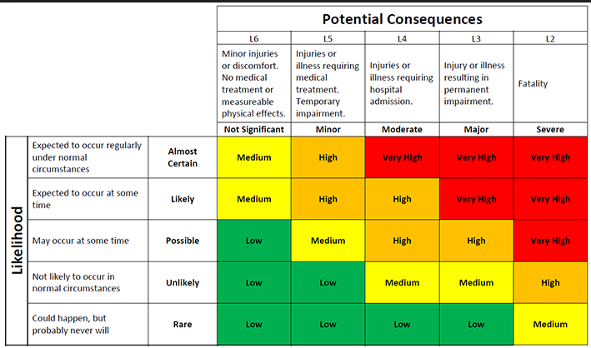

Hazard Register
- The following is the hazard register:
ID No. | Description | Causing threat of
H001 | Rough access road prone to obstructions and slips | Rough ride  Damage  Vehicle stuck
H002 | Bodies of water | Drowning  Vehicle stuck
H003 | Surrounding cliffs and rocks | Fall from height  Slip from height
H004 | Sharp items throughout the area | Cuts
H005 | Uneven ground | Causing falls
H006 | Eco toilets and shared toilets | Bacteria and infection
H007 | Unpermitted buildings | Dampness  Rough edges  Instability
H008 | Remote location | Isolation from normal services  Isolation from support
H009 | Vehicles and pedestrian in same area | Injury to pedestrian  Vehicle and pedestrian contact
H010 | Vehicles and tents in same area | Injury to pedestrian  Damage to property
H011 | Temporary kitchens | Heat and hot water injury  Gas threats  Contamination and bacteria threats
H012 | Temporary mass visitors | Ablution facilities  Water availability  Heat and cold management  Traffic management  Hazard awareness  Safety behaviour
H013 | Alluvial fan | Flooding  Slips  Wash-out
H014 | Sun damage | Sunburn  Melanoma
H015 | Cold Weather affect | Cold  Hypothermia  Cold and flue
H016 | Alluvial Fan | Flooding  Falls cliffs and debris
H017 | Subsiding land and rock fall from cliffs | Flooding  Landslip  Rock falls

Keep Safe Register
- The following is the ‘Keep Safe Register’:
ID No. | Description | Resulting in
KS01 | Ensure you have a suitable vehicle for the terrain and weather | Safe trip, incident free trip
KS02 | Ensure you bring enough equipment to keep sheltered, safe and fed. | Comfortable trip
KS03 | Ensure you keep an eye on children who are swimming or crossing water | No drowning or injury
KS04 | Ensure you know where your children are | Safe children
KSO5 | Ensure you only use equipment you are trained to use | No injury or incident
KS06 | Ensure you wash your hands regularly as well as dishes | No bacteria related issues
KS07 | Ensure cars are parked away from tents | No injury or damage
KS08 | Ensure you keep an eye on friends and family to ensure they are safe | Everyone safe
KS09 | Bring a first aid kit | Manage own injuries
KS10 | Ensure your phone is fully charge and spare charge | Call for assistance
KS11 | Bring bottled water | Keep hydrated
KS12 | Bring clothing suitable for a range of weather | Keep cool and keep warm
KS13 | Build Only with known risks | Injury  Destruction of property
KS15 | Leave safe distances between yourself/buildings and cliffs | Injury  Destruction of property
KS15 | Do not build or camp in alluvial fan | Injury  Destruction of property

Attachment 1 – Acknowledgement of Safety Policy

All visitors to the Reservation are required to sign this policy, excluding manuhiri at official hapū events.
In particular, people operating equipment or operating in the bush, cliffs or water areas are required to acknowledge that they have read and understood the Trust Safety Policy.

Acknowledgement of Safety Policy

I ____________________________________________________ [Full Name] who works for
_____________________________________________ [Company] acknowledge that I have read and understood the Safety Policy of the Whanganui Bay Māori Reservation Trust.

I have been given permission to be on the Reservation by _______________________________ [Name of Trustee] and this has been confirmed in writing – a copy of which I have in my possession during my visit.

Date: ______________________________________
Signature: __________________________________
Copy to be filed with Trust through Ordinary Meeting.

